Unit-1
1.1 Functional unit
A computer consists of five functionally independent main parts input, memory, arithmetic logic unit (ALU), output and control unit.
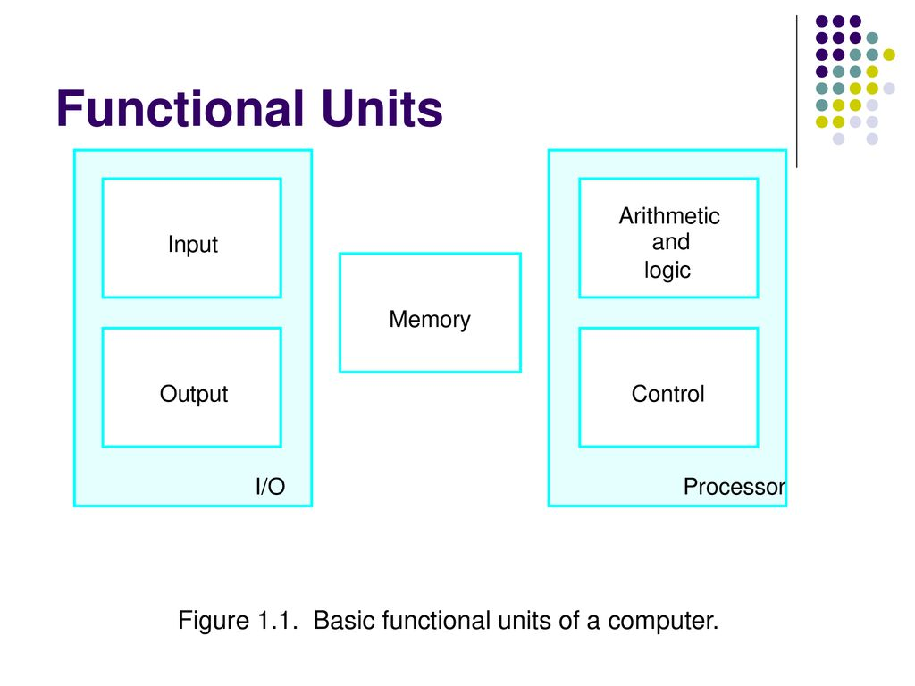
Fig a : Functional units of computer
Input device accepts the coded information as source program i.e. high level
language. This is either stored in the memory or immediately used by the processor to perform the desired operations. The program stored in the memory determines the processing steps. Basically the computer converts one source program to an object program. i.e. into machine language.
Finally the results are sent to the outside world through output device. All of
these actions are coordinated by the control unit.
Input unit: -
The source program/high level language program/coded information/simply data is fed to a computer through input devices keyboard is a most common type. Whenever a key is pressed, one corresponding word or number is translated into its equivalent binary code over a cable & fed either to memory or processor.
Joysticks, trackballs, mouse, scanners etc are other input devices.
Memory unit: -
Its function into store programs and data. It is basically to two types
1. Primary memory
2. Secondary memory
1. Primary memory: - Is the one exclusively associated with the processor and operates at the electronics speeds programs must be stored in this memory while they are being executed. The memory contains a large number of semiconductors storage cells. Each capable of storing one bit of information. These are processed in a group of fixed site called word.
To provide easy access to a word in memory, a distinct address is associated with each word location. Addresses are numbers that identify memory location. Number of bits in each word is called word length of the computer. Programs must reside in the memory during execution. Instructions and data can be written into the memory or read out under the control of processor.
Memory in which any location can be reached in a short and fixed amount of time after specifying its address is called random-access memory (RAM).
The time required to access one word in called memory access time. Memory
which is only readable by the user and contents of which can’t be altered is called read only memory (ROM) it contains operating system.
Caches are the small fast RAM units, which are coupled with the processor and are aften contained on the same IC chip to achieve high performance. Although primary storage is essential it tends to be expensive.
2 Secondary memory: - Is used where large amounts of data & programs have to be stored, particularly information that is accessed infrequently.
Examples: - Magnetic disks & tapes, optical disks (ie CD-ROM’s), floppies etc.,
Arithmetic logic unit (ALU):-
Most of the computer operators are executed in ALU of the processor like
addition, subtraction, division, multiplication, etc. the operands are brought into the ALU from memory and stored in high speed storage elements called register. Then according to the instructions the operation is performed in the required sequence.
The control and the ALU are may times faster than other devices connected to a computer system. This enables a single processor to control a number of external devices such as key boards, displays, magnetic and optical disks, sensors and other mechanical controllers.
Output unit:-
These actually are the counterparts of input unit. Its basic function is to send the processed results to the outside world.
Examples:- Printer, speakers, monitor etc.
Control unit:-
It effectively is the nerve center that sends signals to other units and senses their states. The actual timing signals that govern the transfer of data between input unit, processor, memory and output unit are generated by the control unit.

1.2 Introduction of Multiprocessor and Multicomputer

Multiprocessor
A Multiprocessor is a computer system with two or more central processing units (CPUs) share full access to a common RAM. The main objective of using a multiprocessor is to boost the system’s execution speed, with other objectives being fault tolerance and application matching. There are two types of multiprocessors, one is called shared memory multiprocessor and another is distributed memory multiprocessor. In shared memory multiprocessors, all the CPUs share the common memory but in a distributed memory multiprocessor, every CPU has its own private memory.

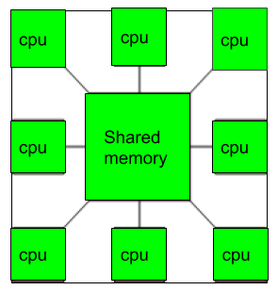

Benefits of using a Multiprocessor
Improved performance: Multiprocessor systems can execute tasks faster than single-processor systems, as the workload can be distributed across multiple processors.
Better scalability: Multiprocessor systems can be scaled more easily than single-processor systems, as additional processors can be added to the system to handle increased workloads.
Increased reliability: Multiprocessor systems can continue to operate even if one processor fails, as the remaining processors can continue to execute tasks.
Reduced cost: Multiprocessor systems can be more cost-effective than building multiple single-processor systems to handle the same workload.
Enhanced parallelism: Multiprocessor systems allow for greater parallelism, as different processors can execute different tasks simultaneously.
Disadvantages:
Increased complexity: Multiprocessor systems are more complex than single-processor systems, and they require additional hardware, software, and management resources.
Higher power consumption: Multiprocessor systems require more power to operate than single-processor systems, which can increase the cost of operating and maintaining the system.
Difficult programming: Developing software that can effectively utilize multiple processors can be challenging, and it requires specialized programming skills.
Synchronization issues: Multiprocessor systems require synchronization between processors to ensure that tasks are executed correctly and efficiently, which can add complexity and overhead to the system.
Limited performance gains: Not all applications can benefit from multiprocessor systems, and some applications may only see limited performance gains when running on a multiprocessor system.
Multicomputer
A multicomputer system is a computer system with multiple processors that are connected together to solve a problem. Each processor has its own memory and it is accessible by that particular processor and those processors can communicate with each other via an interconnection network.

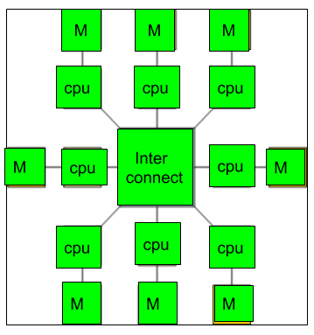
As the multicomputer is capable of messages passing between the processors, it is possible to divide the task between the processors to complete the task. Hence, a multicomputer can be used for distributed computing. It is cost effective and easier to build a multicomputer than a multiprocessor.
Difference between multiprocessor and Multicomputer:
- Multiprocessor is a system with two or more central processing units (CPUs) that is capable of performing multiple tasks where as a multicomputer is a system with multiple processors that are attached via an interconnection network to perform a computation task.
- A multiprocessor system is a single computer that operates with multiple CPUs where as a multicomputer system is a cluster of computers that operate as a singular computer.
- Construction of multicomputer is easier and cost effective than a multiprocessor.
- In multiprocessor system, program tends to be easier where as in multicomputer system, program tends to be more difficult.
- Multiprocessor supports parallel computing, Multicomputer supports distributed computing.
Advantages:
Improved performance: Multicomputer systems can execute tasks faster than single-computer systems, as the workload can be distributed across multiple computers.
Better scalability: Multicomputer systems can be scaled more easily than single-computer systems, as additional computers can be added to the system to handle increased workloads.
Increased reliability: Multicomputer systems can continue to operate even if one computer fails, as the remaining computers can continue to execute tasks.
Reduced cost: Multicomputer systems can be more cost-effective than building a single large computer system to handle the same workload.
Enhanced parallelism: Multicomputer systems allow for greater parallelism, as different computers can execute different tasks simultaneously.
Disadvantages:
Increased complexity: Multicomputer systems are more complex than single-computer systems, and they require additional hardware, software, and management resources.
Higher power consumption: Multicomputer systems require more power to operate than single-computer systems, which can increase the cost of operating and maintaining the system.
Difficult programming: Developing software that can effectively utilize multiple computers can be challenging, and it requires specialized programming skills.
Synchronization issues: Multicomputer systems require synchronization between computers to ensure that tasks are executed correctly and efficiently, which can add complexity and overhead to the system.
Network latency: Multicomputer systems rely on a network to communicate between computers, and network latency can impact system performance.
1.3 Memory locations and addresses
Number and character operands, as well as instructions, are stored in the memory of a computer. The memory consists of many millions of storage cells, each of which can store a bit of information having the value 0 or 1. Because a single bit represents a very small amount of information, bits are seldom handled individually. The usual approach is to deal with them in groups of fixed size. For this purpose, the memory is organized so that a group of n bits can be stored or retrieved in a single, basic operation. Each group of
n bits is referred to as a word of information, and n is called the word length. The memory of a computer can be schematically represented as a collection of words as shown in figure (a).
Modern computers have word lengths that typically range from 16 to 64 bits. If the word length of a computer is 32 bits, a single word can store a 32-bit 2’s complement number or four ASCII characters, each occupying 8 bits. A unit of 8 bits is called a byte.
Accessing the memory to store or retrieve a single item of information, either a word or a byte, requires distinct names or addresses for each item location. It is customary to use numbers from 0 through 2K-1, for some suitable values of k, as the addresses of successive locations in the memory. The 2k addresses constitute the address space of the computer, and the memory can have up to 2k addressable locations. 24-bit address generates an address space of 224 (16,777,216) locations. A 32-bit address creates an address space of 232 or 4G (4 giga) locations.
BYTE ADDRESSABILITY:-
We now have three basic information quantities to deal with: the bit, byte and word. A byte is always 8 bits, but the word length typically ranges from 16 to 64 bits. The most practical assignment is to have successive addresses refer to successive byte
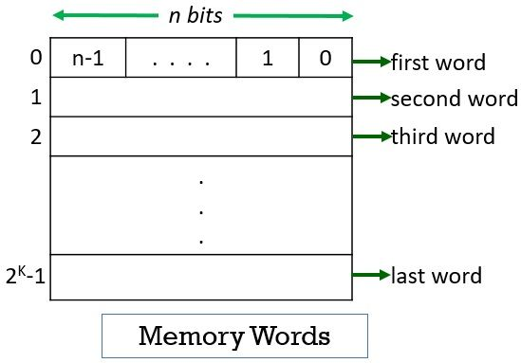
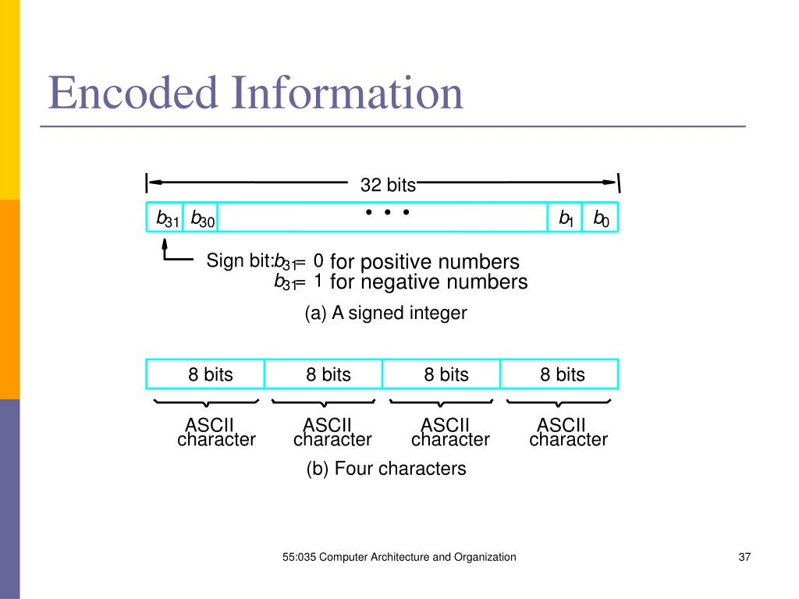
Locations in the memory. This is the assignment used in most modern computers, and is the one we will normally use in this book. The term byte-addressable memory is use for this assignment. Byte locations have addresses 0,1,2, …. Thus, if the word length of the machine is 32 bits, successive words are located at addresses 0,4,8,…., with each word consisting of four bytes.
BIG-ENDIAN AND LITTLE-ENDIAN ASIGNMENTS:-
There are two ways that byte addresses can be assigned across words, as shown in fig b. The name big-endian is used when lower byte addresses are used for the more significant bytes (the leftmost bytes) of the word. The name little-endian is used for the opposite ordering, where the lower byte addresses are used for the less significant bytes (the rightmost bytes) of the word.
In addition to specifying the address ordering of bytes within a word, it is also necessary to specify the labeling of bits within a byte or a word. The same ordering is also used for labeling bits within a byte, that is, b7, b6, …., b0, from left to right
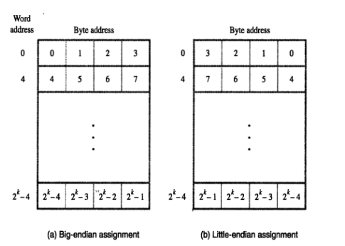.
WORD ALIGNMENT:-
In the case of a 32-bit word length, natural word boundaries occur at addresses 0, 4, 8, …, as shown in above fig. We say that the word locations have aligned addresses . in general, words are said to be aligned in memory if they begin at a byte address that is a multiple of the number of bytes in a word. The memory of bytes in a word is a power of 2. Hence, if the word length is 16 (2 bytes), aligned words begin at byte addresses 0,2,4,…, and for a word length of 64 (23 bytes), aligned words begin at bytes addresses 0,8,16 ….
There is no fundamental reason why words cannot begin at an arbitrary byte address. In that case, words are said to have unaligned addresses. While the most common case is to use aligned addresses, some computers allow the use of unaligned word addresses.
ACCESSING NUMBERS, CHARACTERS, AND CHARACTER STRINGS:-
A number usually occupies one word. It can be accessed in the memory by specifying its word address. Similarly, individual characters can be accessed by their byte address.
In many applications, it is necessary to handle character strings of variable length. The beginning of the string is indicated by giving the address of the byte containing its first character. Successive byte locations contain successive characters of the string. There are two ways to indicate the length of the string. A special control character with the meaning “end of string” can be used as the last character in the string, or a separate memory word location or processor register can contain a number indicating the length of the string in bytes.
1.4 Memory operations
Both program instructions and data operands are stored in the memory. To execute an instruction, the processor control circuits must cause the word (or words) containing the instruction to be transferred from the memory to the processor. Operands and results must also be moved between the memory and the processor. Thus, two basic operations involving the memory are needed, namely, Load (or Read or Fetch) and Store (or Write).
The load operation transfers a copy of the contents of a specific memory location to the processor. The memory contents remain unchanged. To start a Load operation, the processor sends the address of the desired location to the memory and requests that its contents be read. The memory reads the data stored at that address and sends them to the processor.
The store operation transfers an item of information from the processor to a specific memory location, destroying the former contents of that location. The processor sends the address of the desired location to the memory, together with the data to be written into that location.
An information item of either one word or one byte can be transferred between the processor and the memory in a single operation. Actually this transfer in between the CPU register & main memory.
1.5 Instructions and instruction sequencing
A computer must have instructions capable of performing four types of operations.
• Data transfers between the memory and the processor registers
• Arithmetic and logic operations on data
• Program sequencing and control
• I/O transfers
REGISTER TRANSFER NOTATION:-
Transfer of information from one location in the computer to another. Possible locations that may be involved in such transfers are memory locations that may be involved in such transfers are memory locations, processor registers, or registers in the I/O subsystem. Most of the time, we identify a location by a symbolic name standing for its hardware binary address.
Example, names for the addresses of memory locations may be LOC, PLACE, A, VAR2; processor registers names may be R0, R5; and I/O register names may be DATAIN, OUTSTATUS, and so on. The contents of a location are denoted by placing square brackets around the name of the location. Thus, the expression
R1[LOC]
Means that the contents of memory location LOC are transferred into processor register R1.
As another example, consider the operation that adds the contents of registers R1 and R2, and then places their sum into register R3. This action is indicated as
R3 [R1] + [R2]
This type of notation is known as Register Transfer Notation (RTN). Note that the right-hand side of an RTN expression always denotes a value, and the left-hand side is the name of a location where the value is to be places, overwriting the old contents of that location.
ASSEMBLY LANGUAGE NOTATION:-
Another type of notation to represent machine instructions and programs. For this, we use an assembly language format. For example, an instruction that causes the transfer described above, from memory location LOC to processor register R1, is specified by the statement
Move LOC, R1
The contents of LOC are unchanged by the execution of this instruction, but the old contents of register R1 are overwritten. The second example of adding two numbers contained in processor registers R1 and R2 and placing their sum in R3 can be specified by the assembly language statement Add R1, R2, R3
BASIC INSTRUCTIONS:-
The operation of adding two numbers is a fundamental capability in any computer. The statement C = A + B In a high-level language program is a command to the computer to add the current values of the two variables called A and B, and to assign the sum to a third variable, C. When the program containing this statement is compiled, the three variables, A, B, and C, are assigned to distinct locations in the memory. We will use the variable names to refer to the corresponding memory location addresses. The contents of these locations represent the values of the three variables. Hence, the above high-level language statement requires the action.
C =[A] + [B]
To carry out this action, the contents of memory locations A and B are fetched from the memory and transferred into the processor where their sum is computed. This result is then sent back to the memory and stored in location C.
Let us first assume that this action is to be accomplished by a single machine instruction. Furthermore, assume that this instruction contains the memory addresses ofthe three operands – A, B, and C. This three-address instruction can be represented symbolically as
Add A, B, C
Operands A and B are called the source operands, C is called the destination operand, and Add is the operation to be performed on the operands. A general instruction of this type has the format.
Operation Source1, Source 2, Destination
If k bits are needed for specify the memory address of each operand, the encoded form of the above instruction must contain 3k bits for addressing purposes in addition to the bits needed to denote the Add operation. An alternative approach is to use a sequence of simpler instructions to perform the same task, with each instruction having only one or two operands. Suppose that two- address instructions of the form
Operation Source, Destination
Are available. An Add instruction of this type is
Add A, B
Which performs the operation B= [A] + [B].
A single two-address instruction cannot be used to solve our original problem, which is to add the contents of locations A and B, without destroying either of them, and to place the sum in location C. The problem can be solved by using another two-address instruction that copies the contents of one memory location into another. Such an instruction is
Move B, C
Which performs the operations C 􀯭 [B], leaving the contents of location B unchanged. Using only one-address instructions, the operation C= [A] + [B] can be performed by executing the sequence of instructions
Load A
Add B
Store C
Some early computers were designed around a single accumulator structure. Most modern computers have a number of general-purpose processor registers – typically8 to 32, and even considerably more in some cases. Access to data in these registers is much faster than to data stored in memory locations because the registers are inside the processor.
Let Ri represent a general-purpose register. The instructions
Load A, Ri
Store Ri, A and
Add A, Ri
Are generalizations of the Load, Store, and Add instructions for the single-accumulator case, in which register Ri performs the function of the accumulator.
When a processor has several general-purpose registers, many instructions involve only operands that are in the register. In fact, in many modern processors, computations can be performed directly only on data held in processor registers.
Instructions such as
Add Ri, Rj
Or
Add Ri, Rj, Rk
In both of these instructions, the source operands are the contents of registers Ri and Rj. In the first instruction, Rj also serves as the destination register, whereas in the second instruction, a third register, Rk, is used as the destination.
It is often necessary to transfer data between different locations. This is achieved with the instruction
Move Source, Destination
When data are moved to or from a processor register, the Move instruction can be used rather than the Load or Store instructions because the order of the source and destination operands determines which operation is intended. Thus,
Move A, Ri
Is the same as
Load A, Ri
And
Move Ri, A
Is the same as
Store Ri, A
In processors where arithmetic operations are allowed only on operands that are processor registers, the C = A + B task can be performed by the instruction sequence
Move A, Ri
Move B, Rj
Add Ri, Rj
Move Rj, C
In processors where one operand may be in the memory but the other must be in register, an instruction sequence for the required task would be
Move A, Ri
Add B, Ri
Move Ri, C
The speed with which a given task is carried out depends on the time it takes to transfer instructions from memory into the processor and to access the operands referenced by these instructions. Transfers that involve the memory are much slower than transfers within the processor.
We have discussed three-, two-, and one-address instructions. It is also possible to use instructions in which the locations of all operands are defined implicitly. Such instructions are found in machines that store operands in a structure called a pushdown stack. In this case, the instructions are called zero-address instructions.
INSTRUCTION EXECUTION AND STRAIGHT-LINE SEQUENCING:-
In the preceding discussion of instruction formats, we used to task C [B]. fig 2.8 shows a possible program segment for this task as it appears in the memory of a computer. We have assumed that the computer allows one memory operand per instruction and has a number of processor registers. The three instructions of the program are in successive word locations, starting at location i. since each instruction is 4 bytes long, the second and third instructions start at addresses i + 4 and i + 8.
Let us consider how this program is executed. The processor contains a register called the program counter (PC), which holds the address of the instruction to be executed next. To begin executing a program, the address of its first instruction (I in our example) must be placed into the PC. Then, the processor control circuits use the information in the PC to fetch and execute instructions, one at a time, in the order of increasing addresses. This is called straight-line sequencing. During the execution of each instruction, the PC is incremented by 4 to point to the next instruction. Thus, after the Move instruction at location i + 8 is executed, the PC contains the value i + 12, which is the address of the first instruction of the next program segment.
Executing a given instruction is a two-phase procedure. In the first phase, called instruction fetch, the instruction is fetched from the memory location whose address is in the PC. This instruction is placed in the instruction register (IR) in the processor. The instruction in IR is examined to determine which operation is to be performed. The specified operation is then performed by

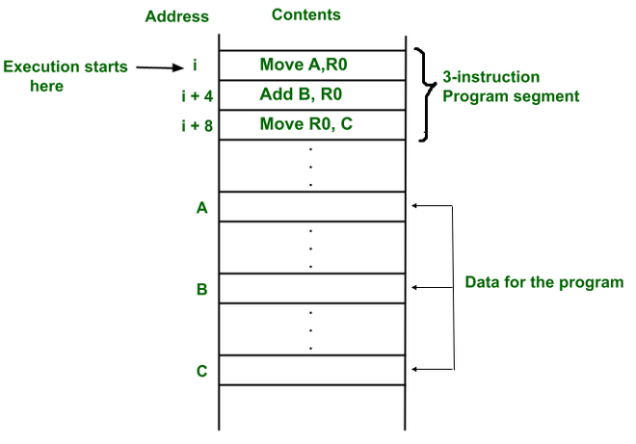
the processor. This often involves fetching operands from the memory or from processor registers, performing an arithmetic or logic operation, and storing the result in the destination location.
BRANCHING:-
Consider the task of adding a list of n numbers. Instead of using a long list of add instructions, it is possible to place a single add instruction in a program loop, as shown in fig b. The loop is a straight-line sequence of instructions executed as many times as needed. It starts at location LOOP and ends at the instruction Branch > 0. During each pass through this loop, the address of the next list entry is determined, and that entry is fetched and added to
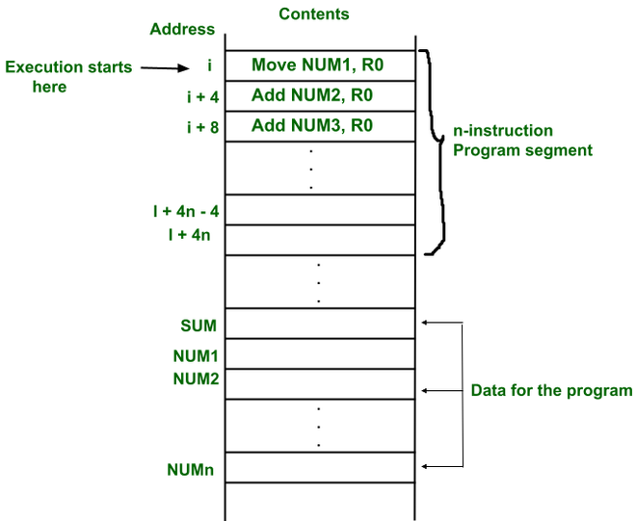
fig a A straight-line program for adding n numbers
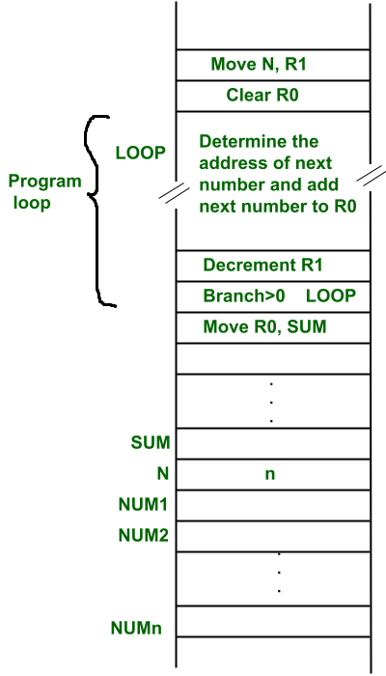
Fig b Using a loop to add n numbers
Assume that the number of entries in the list, n, is stored in memory location N, as shown. Register R1 is used as a counter to determine the number of time the loop is executed. Hence, the contents of location N are loaded into register R1 at the beginning of the program. Then, within the body of the loop, the instruction.
Decrement R1
Reduces the contents of R1 by 1 each time through the loop.
This type of instruction loads a new value into the program counter. As a result, the processor fetches and executes the instruction at this new address, called the branch target, instead of the instruction at the location that follows the branch instruction in sequential address order. A conditional branch instruction causes a branch only if a specified condition is satisfied. If the condition is not satisfied, the PC is incremented in the normal way, and the next instruction in sequential address order is fetched and executed.
Branch > 0 LOOP
(branch if greater that 0) is a conditional branch instruction that causes a branch to location LOOP if the result of the immediately preceding instruction, which is the decremented value in register R1, is greater that zero. This means that the loop is repeated, as long as there are entries in the list that are yet to be added to R0. at the end of the nth pass through the loop, the Decrement instruction produces a value of zero, and hence, branching does not occur.
CONDITION CODES:-
The processor keeps track of information about the results of various operations for use by subsequent conditional branch instructions. This is accomplished by recording the required information in individual bits, often called condition code flags. These flags are usually grouped together in a special processor register called the condition code register or status register. Individual condition code flags are set to 1 or cleared to 0, depending on the outcome of the operation performed. Four commonly used flags are
- N(negative) - Set to 1 if the result is negative; otherwise, cleared to 0
- Z(zero) - Set to 1 if the result is 0; otherwise, cleared to 0
- V(overflow) - Set ot1 if arithmetic overflow occurs; otherwise, cleared to 0
- C(carry) - Set to 1 if a carry-out results from the operation; otherwise, cleared to 0
The instruction Branch > 0, discussed in the previous section, is an example of a branch instruction that tests one or more of the condition flags. It causes a branch if the value tested is neither negative nor equal to zero. That is, the branch is taken if neither N nor Z is 1. The conditions are given as logic expressions involving the condition code flags.
In some computers, the condition code flags are affected automatically by instructions that perform arithmetic or logic operations. However, this is not always the case. A number of computers have two versions of an Add instruction.
GENERATING MEMORY ADDRESSES:-
Let us return to fig b. The purpose of the instruction block at LOOP is to add a different number from the list during each pass through the loop. Hence, the Add instruction in the block must refer to a different address during each pass. How are the addresses to be specified ? The memory operand address cannot be given directly in a single Add instruction in the loop. Otherwise, it would need to be modified on each pass through the loop.
The instruction set of a computer typically provides a number of such methods, called addressing modes. While the details differ from one computer to another, the underlying concepts are the same.
1.6 Addressing modes:
In general, a program operates on data that reside in the computer’s memory.
These data can be organized in a variety of ways. If we want to keep track of students’ names, we can write them in a list. Programmers use organizations called data structures to represent the data used in computations. These include lists, linked lists, arrays, queues, and so on.
Programs are normally written in a high-level language, which enables the programmer to use constants, local and global variables, pointers, and arrays. The different ways in which the location of an operand is specified in an instruction are referred to as addressing modes.
Table 2.1 Generic addressing modes
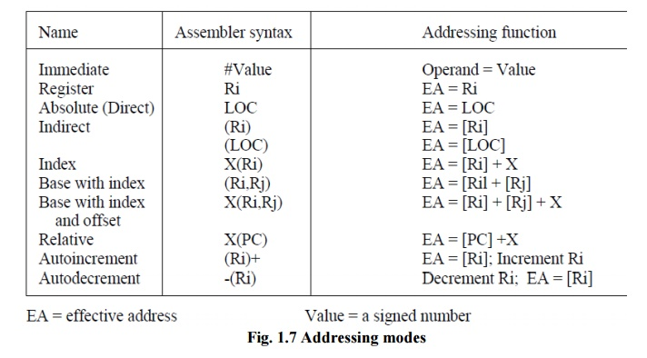
IMPLEMENTATION OF VARIABLE AND CONSTANTS:-
Variables and constants are the simplest data types and are found in almost every computer program. In assembly language, a variable is represented by allocating a register or memory location to hold its value. Thus, the value can be changed as needed using appropriate instructions.
Register mode - The operand is the contents of a processor register; the name (address) of the register is given in the instruction.
Absolute mode – The operand is in a memory location; the address of this location is given explicitly in the instruction. (In some assembly languages, this mode is called Direct).
The instruction
Move LOC, R2
Processor registers are used as temporary storage locations where the data is a register are accessed using the Register mode. The Absolute mode can represent global variables in a program. A declaration such as
Integer A, B;
Immediate mode – The operand is given explicitly in the instruction.
For example, the instruction
Move 200immediate, R0
Places the value 200 in register R0. Clearly, the Immediate mode is only used to specify the value of a source operand. Using a subscript to denote the Immediate mode is not appropriate in assembly languages. A common convention is to use the sharp sign (#) in front of the value to indicate that this value is to be used as an immediate operand.
Hence, we write the instruction above in the form
Move #200, R0
INDIRECTION AND POINTERS:-
In the addressing modes that follow, the instruction does not give the operand or its address explicitly, Instead, it provides information from which the memory address of the operand can be determined. We refer to this address as the effective address (EA) of the operand.
Indirect mode – The effective address of the operand is the contents of a register or memory location whose address appears in the instruction.
To execute the Add instruction in fig (a), the processor uses the value which is in register R1, as the effective address of the operand. It requests a read operation from the memory to read the contents of location B. the value read is the desired operand, which the processor adds to the contents of register R0. Indirect addressing through a memory location is also possible as shown in fig (b). In this case, the processor first reads the contents of memory location A, then requests a second read operation using the value B as an address to obtain the operand
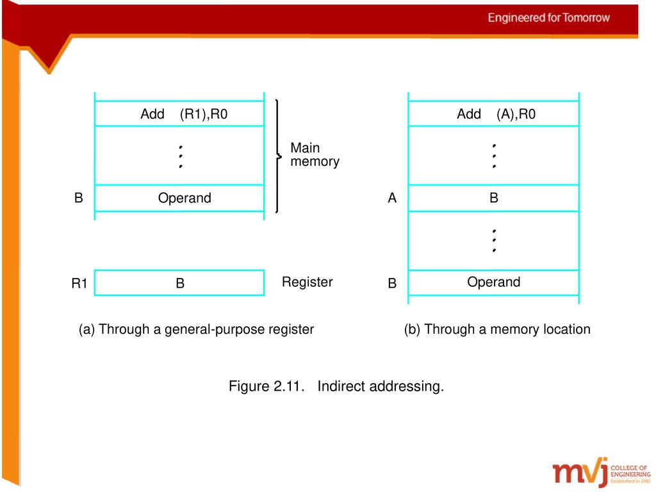
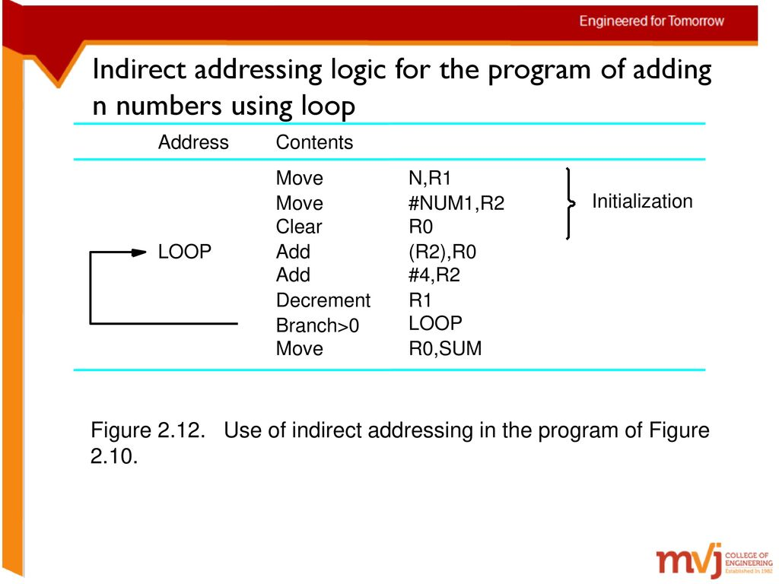
In the program shown Register R2 is used as a pointer to the numbers in the list, and the operands are accessed indirectly through R2. The initialization section of the program loads the counter value n from memory location N into R1 and uses the immediate addressing mode to place the address value NUM1, which is the address of the first number in the list, into R2. Then it clears R0 to 0. The first two instructions in the loop implement the unspecified instruction block starting at LOOP. The first time through the loop, the instruction Add (R2), R0 fetches the operand at location NUM1 and adds it to R0. The second Add instruction adds 4 to the contents of the pointer R2, so that it will contain the address value NUM2 when the above instruction is executed in the second pass through the loop. Where B is a pointer variable. This statement may be compiled into
Move B, R1
Move (R1), A
Using indirect addressing through memory, the same action can be achieved with
Move (B), A
Indirect addressing through registers is used extensively. The above program
shows the flexibility it provides. Also, when absolute addressing is not vailable, indirect addressing through registers makes it possible to access global variables by first loading the operand’s address in a register.
INDEXING AND ARRAYS:-
A different kind of flexibility for accessing operands is useful in dealing with
lists and arrays.
Index mode – the effective address of the operand is generated by adding a constant
value to the contents of a register.
The register use may be either a special register provided for this purpose, or,
more commonly, it may be any one of a set of general-purpose registers in the processor.
In either case, it is referred to as index register. We indicate the Index mode symbolically
as
X (Ri)
Where X denotes the constant value contained in the instruction and Ri is the
name of the register involved. The effective address of the operand is given by
EA = X + [Rj]
The contents of the index register are not changed in the process of generating the effective address. In an assembly language program, the constant X may be given either as an explicit number or as a symbolic name representing a numerical value.
Fig a illustrates two ways of using the Index mode. In fig a, the index register, R1, contains the address of a memory location, and the value X defines an offset (also called a displacement) from this address to the location where the operand is found. An alternative use is illustrated in fig b. Here, the constant X corresponds to a memory address, and the contents of the index register define the offset to the operand. In either
case, the effective address is the sum of two values; one is given explicitly in the instruction, and the other is stored in a register.
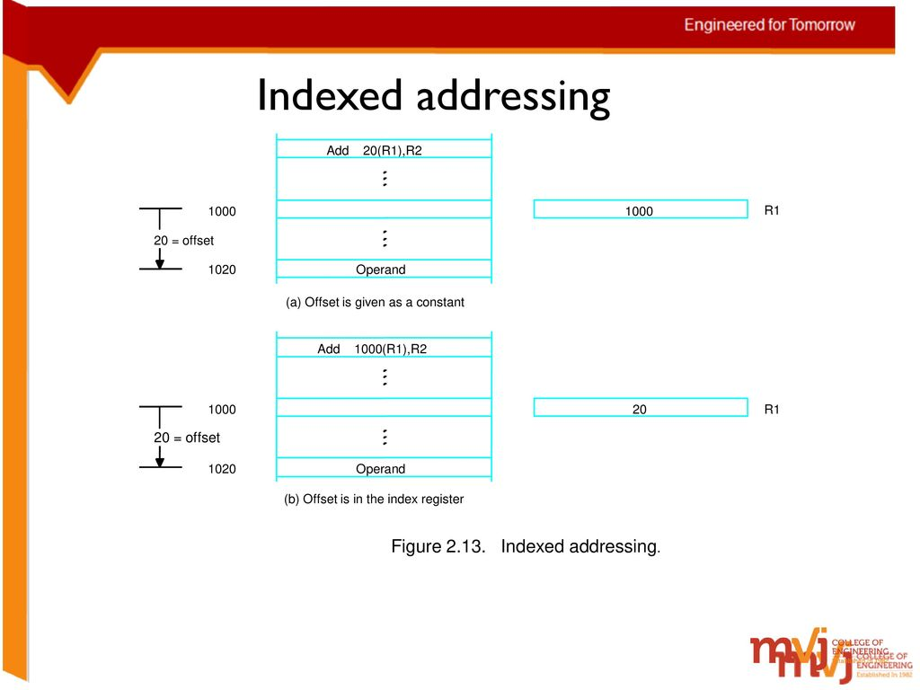
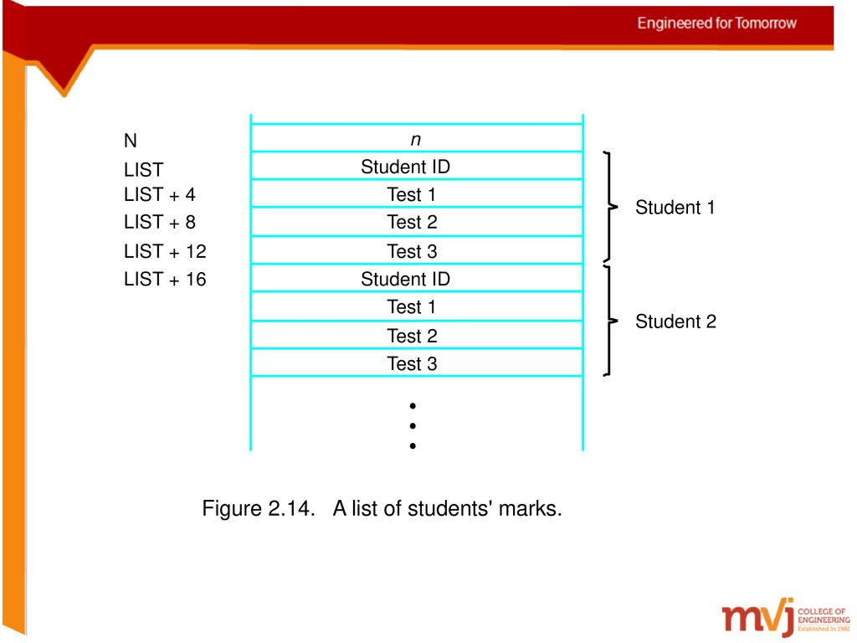
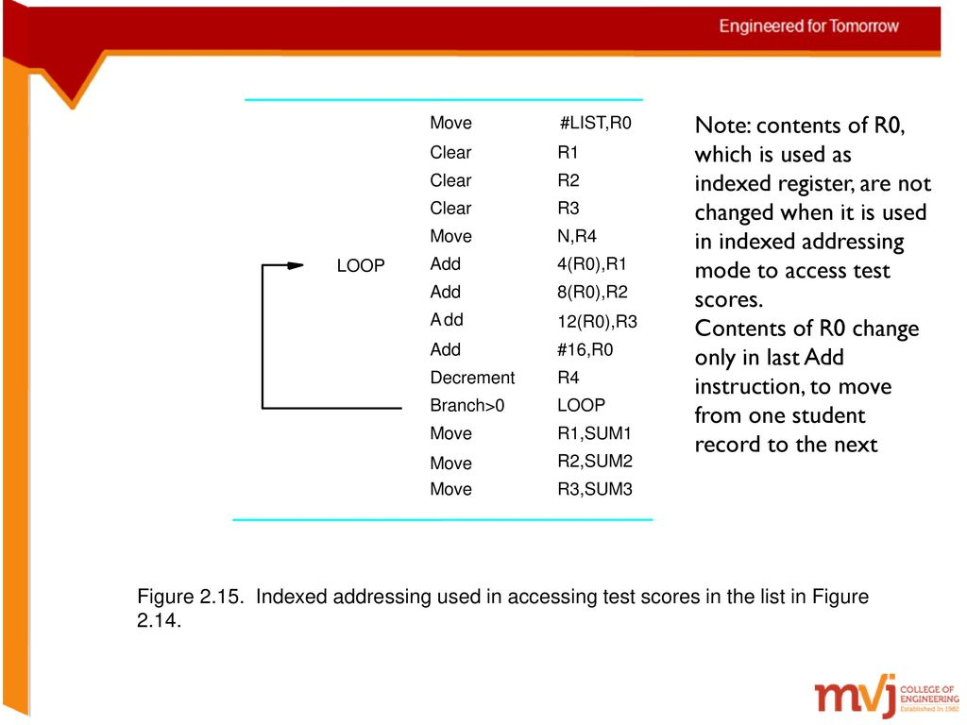
In the most basic form of indexed addressing several variations of this basic form provide a very efficient access to memory operands in practical programming situations. For example, a second register may be used to contain the offset X, in which case we can write the Index mode as
(Ri, Rj)
The effective address is the sum of the contents of registers Ri and Rj. The second register is usually called the base register. This form of indexed addressing provides more flexibility in accessing operands, because both components of the effective address can be changed.
Another version of the Index mode uses two registers plus a constant, which can
be denoted as
X(Ri, Rj)
In this case, the effective address is the sum of the constant X and the contents of
registers Ri and Rj. This added flexibility is useful in accessing multiple components inside each item in a record, where the beginning of an item is specified by the (Ri, Rj) part of the addressing mode. In other words, this mode implements a three-dimensional array.
RELATIVE ADDRESSING:-
We have defined the Index mode using general-purpose processor registers. A
useful version of this mode is obtained if the program counter, PC, is used instead of a general purpose register. Then, X(PC) can be used to address a memory location that is X bytes away from the location presently pointed to by the program counter.
Relative mode – The effective address is determined by the Index mode using the program counter in place of the general-purpose register Ri.
This mode can be used to access data operands. But, its most common use is to
specify the target address in branch instructions. An instruction such as
Branch > 0 LOOP
Causes program execution to go to the branch target location identified by the
name LOOP if the branch condition is satisfied. This location can be computed by
specifying it as an offset from the current value of the program counter. Since the branch target may be either before or after the branch instruction, the offset is given as a signed number.
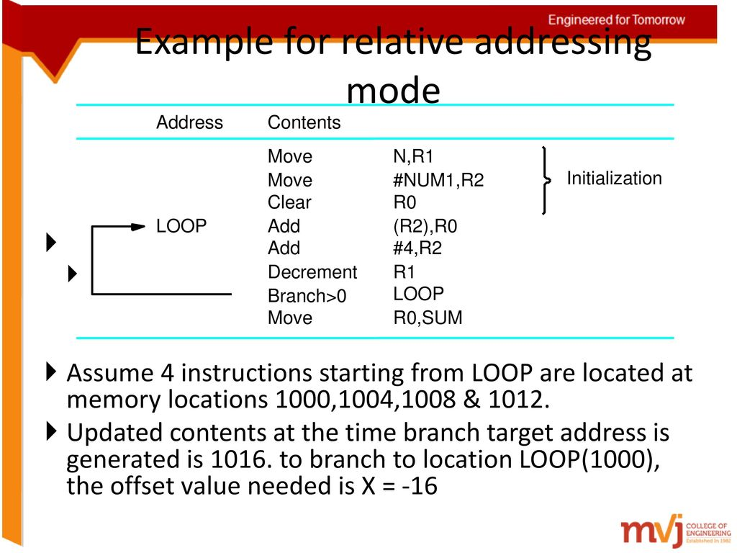
Autoincrement mode – the effective address of the operand is the contents of a register specified in the instruction. After accessing the operand, the contents of this register are automatically to point to the next item in a list.
(Ri)+
Autodecrement mode – the contents of a register specified in the instruction are first automatically decremented and are then used as the effective address of the operand
(Ri)-
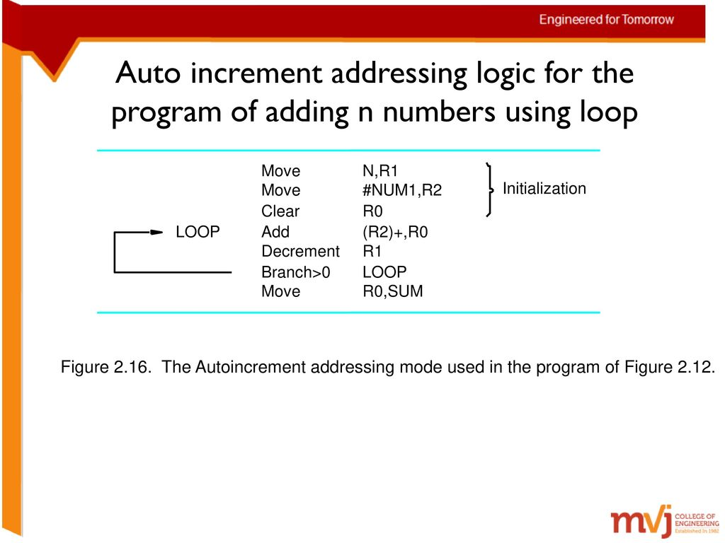
1.7 ASSEMBLY LANGUAGE
Machine instructions are represented by patterns of 0s and 1s. Such patterns are
awkward to deal with when discussing or preparing programs. Therefore, we use
symbolic names to represent the pattern. So far, we have used normal words, such as Move, Add, Increment, and Branch, for the instruction operations to represent the corresponding binary code patterns. When writing programs for a specific computer, such words are normally replaced by acronyms called mnemonics, such as MOV, ADD, INC, and BR. Similarly, we use the notation R3 to refer to register 3, and LOC to refer to a memory location. A complete set of such symbolic names and rules for their use constitute a programming language, generally referred to as an assembly language. Programs written in an assembly language can be automatically translated into a sequence of machine instructions by a program called an assembler. When the assembler program is executed, it reads the user program, analyzes it, and then generates the desired machine language program. The latter contains patterns of 0s and 1s specifying
instructions that will be executed by the computer. The user program in its original alphanumeric text format is called a source program, and the assembled machine language program is called an object program.
ASSEMBLER DIRECTIVES:-
In addition to providing a mechanism for representing instructions in a program,
the assembly language allows the programmer to specify other information needed to translate the source program into the object program. We have already mentioned that we need to assign numerical values to any names used in a program. Suppose that the name SUM is used to represent the value 200. This fact may be conveyed to the assembler program through a statement such as
SUM EQU 200
This statement does not denote an instruction that will be executed when the
object program is run; in fact, it will not even appear in the object program. It simply informs the assembler that the name SUM should be replaced by the value 200 wherever it appears in the program. Such statements, called assembler directives (or commands), are used by the assembler while it translates a source program into an object program.
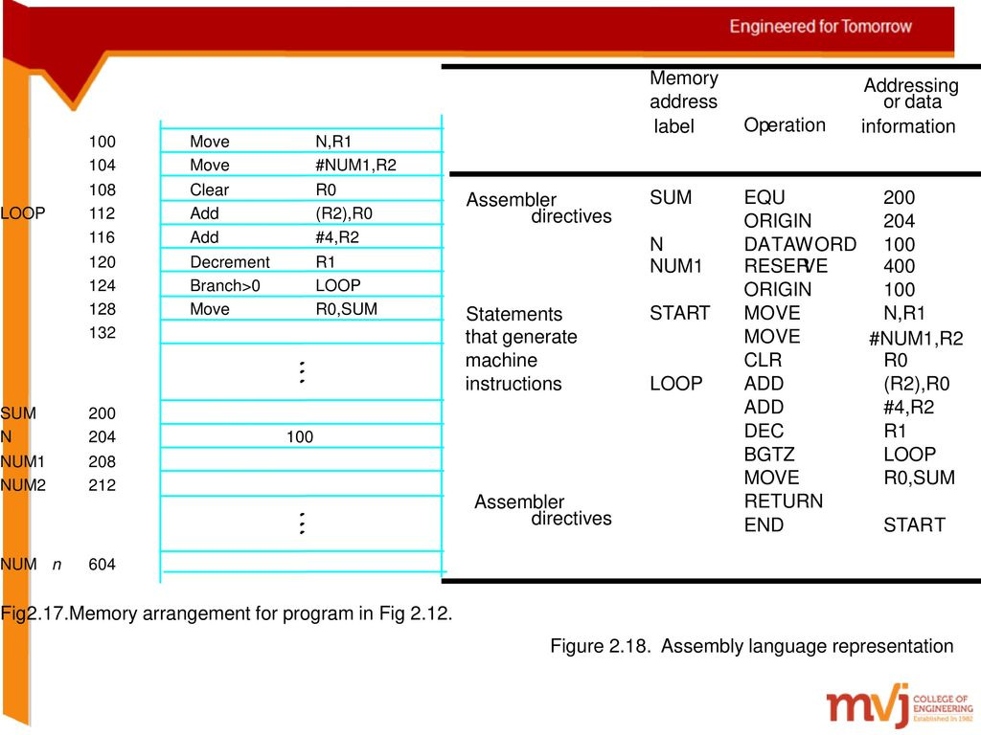
ASSEMBLY AND EXECUTION OF PRGRAMS:-
A source program written in an assembly language must be assembled into a
Machine language object program before it can be executed. This is done by the
Assembler program, which replaces all symbols denoting operations and addressing modes with the binary codes used in machine instructions, and replaces all names and labels with their actual values.
The assembler assigns addresses to instructions and data blocks, starting at the
Address given in the ORIGIN assembler directives. It also inserts constants that may be given in DATAWORD commands and reserves memory space as requested by RESERVE commands.
As the assembler scans through a source programs, it keeps track of all names
and the numerical values that correspond to them in a symbol table. Thus, when a name appears a second time, it is replaced with its value from the table. A problem arises when a name appears as an operand before it is given a value. For example, this happens if a forward branch is required. A simple solution to this problem is to have the assembler scan through the source program twice. During the first pass, it creates a complete symbol table. At the end of this pass, all names will have been assigned numerical values.
The assembler then goes through the source program a second time and substitutes values for all names from the symbol table. Such an assembler is called a two-pass assembler.
The assembler stores the object program on a magnetic disk. The object program
must be loaded into the memory of the computer before it is executed. For this to happen, another utility program called a loader must already be in the memory.
When the object program begins executing, it proceeds to completion unless
there are logical errors in the program. The user must be able to find errors easily. The assembler can detect and report syntax errors. To help the user find other programming errors, the system software usually includes a debugger program. This program enables the user to stop execution of the object program at some points of interest and to examine the contents of various processor registers and memory locations.
NUMBER NOTATION:-
When dealing with numerical values, it is often convenient to use the familiar
decimal notation. Of course, these values are stored in the computer as binary numbers.
In some situations, it is more convenient to specify the binary patterns directly. Most assemblers allow numerical values to be specified in different ways, using conventions that are defined by the assembly language syntax. Consider, for example, the number 93, which is represented by the 8-bit binary number 01011101. If this value is to be used an immediate operand, it can be given as a decimal number, as in the instructions.
ADD #93, R1
Or as a binary number identified by a prefix symbol such as a percent sign, as in
ADD #%01011101, R1
Binary numbers can be written more compactly as hexadecimal, or hex, numbers,
in which four bits are represented by a single hex digit. In hexadecimal representation,
the decimal value 93 becomes 5D. In assembly language, a hex representation is often
identified by a dollar sign prefix. Thus, we would write
ADD #$5D, R1
1.7 Basic input/output operations
We now examine the means by which data are transferred between the memory
of a computer and the outside world. Input/Output (I/O) operations are essential, and the way they are performed can have a significant effect on the performance of the computer.
Consider a task that reads in character input from a keyboard and produces
character output on a display screen. A simple way of performing such I/O tasks is to use a method known as program-controlled I/O. The rate of data transfer from the keyboard to a computer is limited by the typing speed of the user, which is unlikely to exceed a few characters per second. The rate of output transfers from the computer to the display is much higher. It is determined by the rate at which characters can be transmitted over the link between the computer and the display device, typically several thousand characters per second. However, this is still much slower than the speed of a processor that can
execute many millions of instructions per second. The difference in speed between the processor and I/O devices creates the need for mechanisms to synchronize the transfer of data between them.
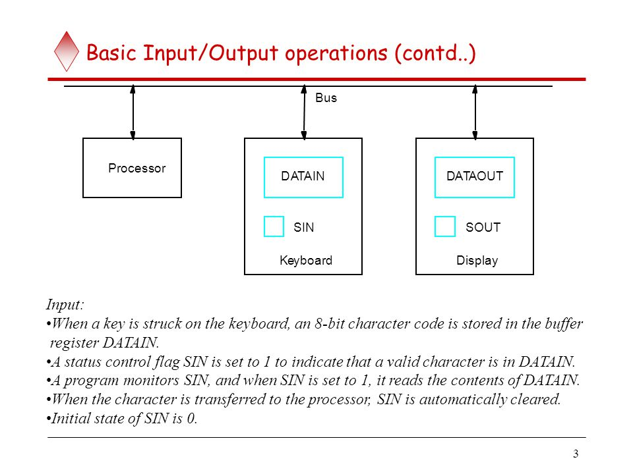

Processor
The keyboard and the display are separate device as shown in fig a. the action of
striking a key on the keyboard does not automatically cause the corresponding character to be displayed on the screen. One block of instructions in the I/O program transfers the character into the processor, and another associated block of instructions causes the character to be displayed.
Striking a key stores the corresponding character code in an 8-bit buffer register
associated with the keyboard. Let us call this register DATAIN, as shown in fig a. To inform the processor that a valid character is in DATAIN, a status control flag, SIN, is set to 1. A program monitors SIN, and when SIN is set to 1, the processor reads the contents of DATAIN. When the character is transferred to the processor, SIN is automatically cleared to 0. If a second character is entered at the keyboard, SIN is again set to 1, and the processor repeats.
An analogous process takes place when characters are transferred from the
processor to the display. A buffer register, DATAOUT, and a status control flag, SOUT, are used for this transfer. When SOUT equals 1, the display is ready to receive a character.
In order to perform I/O transfers, we need machine instructions that can check
the state of the status flags and transfer data between the processor and the I/O device.
These instructions are similar in format to those used for moving data between the processor and the memory. For example, the processor can monitor the keyboard status flag SIN and transfer a character from DATAIN to register R1 by the following sequence of operations.
1.8 Stacks and queues
A computer program often needs to perform a particular subtask using the
familiar subroutine structure. In order to organize the control and information linkage between the main program and the subroutine, a data structure called a stack is used. This section will describe stacks, as well as a closely related data structure called a queue.
Data operated on by a program can be organized in a variety of ways. We have
already encountered data structured as lists. Now, we consider an important data structure known as a stack. A stack is a list of data elements, usually words or bytes, with the accessing restriction that elements can be added or removed at one end of the list only.
This end is called the top of the stack, and the other end is called the bottom. Another descriptive phrase, last-in-first-out (LIFO) stack, is also used to describe this type of storage mechanism; the last data item placed on the stack is the first one removed when retrieval begins. The terms push and pop are used to describe placing a new item on the stack and removing the top item from the stack, respectively.

Fig b shows a stack of word data items in the memory of a computer. It contains
numerical values, with 43 at the bottom and -28 at the top. A processor register is used to keep track of the address of the element of the stack that is at the top at any given time.
This register is called the stack pointer (SP). It could be one of the general-purpose registers or a register dedicated to this function.
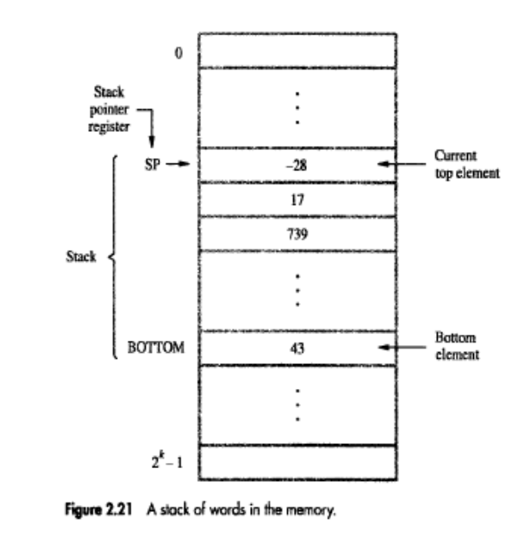
Another useful data structure that is similar to the stack is called a queue. Data
are stored in and retrieved from a queue on a first-in-first-out (FIFO) basis. Thus, if we assume that the queue grows in the direction of increasing addresses in the memory, which is a common practice, new data are added at the back (high-address end) and retrieved from the front (low-address end) of the queue.
There are two important differences between how a stack and a queue are
implemented. One end of the stack is fixed (the bottom), while the other end rises and falls as data are pushed and popped. A single pointer is needed to point to the top of the stack at any given time. On the other hand, both ends of a queue move to higher addresses as data are added at the back and removed from the front. So two pointers are needed to keep track of the two ends of the queue.
Another difference between a stack and a queue is that, without further control, a queue would continuously move through the memory of a computer in the direction of higher addresses. One way to limit the queue to a fixed region in memory is to use a circular buffer. Let us assume that memory addresses from BEGINNING to END are assigned to the queue. The first entry in the queue is entered into location BEGINNING, and successive entries are appended to the queue by entering them at successively higher addresses. By the time the back of the queue reaches END, space will have been created at the beginning if some items have been removed from the queue. Hence, the back pointer is reset to the value BEGINNING and the process continues. As in the case of a stack, care must be taken to detect when the region assigned to the data structure is either completely full or completely empty.
1.9 Subroutines
In a given program, it is often necessary to perform a particular subtask many
times on different data-values. Such a subtask is usually called a subroutine. For example, a subroutine may evaluate the sine function or sort a list of values into increasing or decreasing order.
It is possible to include the block of instructions that constitute a subroutine at
every place where it is needed in the program. However, to save space, only one copy of the instructions that constitute the subroutine is placed in the memory, and any program that requires the use of the subroutine simply branches to its starting location. When a program branches to a subroutine we say that it is calling the subroutine. The instruction that performs this branch operation is named a Call instruction.
After a subroutine has been executed, the calling program must resume execution, continuing immediately after the instruction that called the subroutine. The subroutine is said to return to the program that called it by executing a Return instruction.
The way in which a computer makes it possible to call and return from subroutines is referred to as its subroutine linkage method. The simplest subroutine linkage method is to save the return address in a specific location, which may be a register dedicated to this function. Such a register is called the link register. When the subroutine completes its task, the Return instruction returns to the calling program by branching indirectly through the link register.
The Call instruction is just a special branch instruction that performs the following operations
• Store the contents of the PC in the link register
• Branch to the target address specified by the instruction
The Return instruction is a special branch instruction that performs the operation
• Branch to the address contained in the link register .
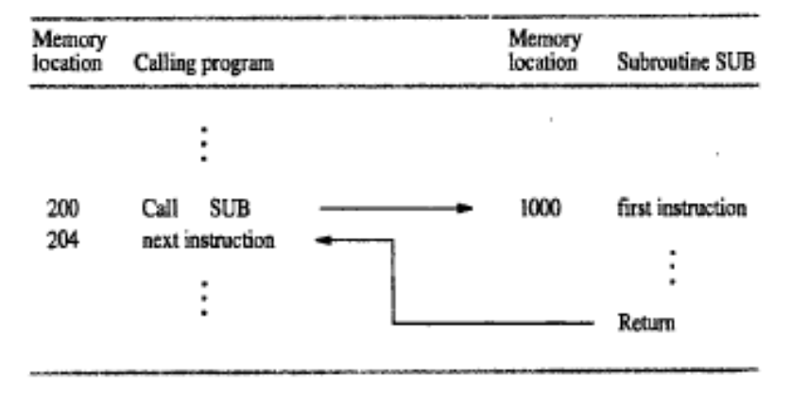
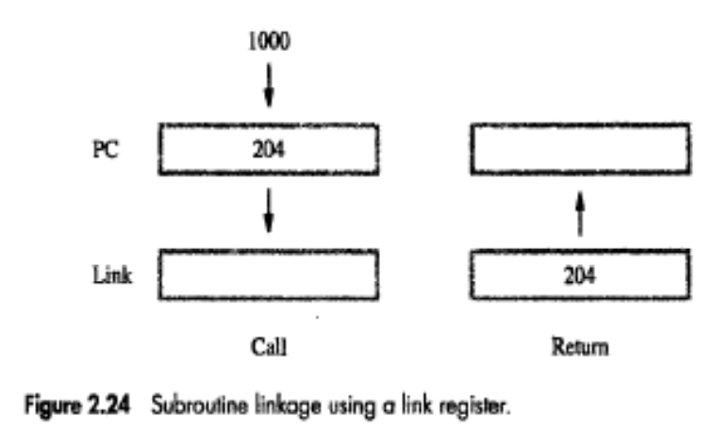
SUBROUTINE NESTING AND THE PROCESSOR STACK:-
A common programming practice, called subroutine nesting, is to have one subroutine call another. In this case, the return address of the second call is also stored in the link register, destroying its previous contents. Hence, it is essential to save the contents of the link register in some other location before calling another subroutine.
Otherwise, the return address of the first subroutine will be lost. Subroutine nesting can be carried out to any depth. Eventually, the last subroutine called completes its computations and returns to the subroutine that called it. The return address needed for this first return is the last one generated in the nested call sequence. That is, return addresses are generated and used in a last-in-first-out order. This suggests that the return addresses associated with subroutine calls should be pushed onto a stack. A particular register is designated as the stack pointer, SP, to be used in this operation. The stack pointer points to a stack called the processor stack. The Call instruction pushes the contents of the PC onto the processor stack and loads the subroutine address into the PC. The Return instruction pops the return address from the processor stack into the PC.
PARAMETER PASSING:-
When calling a subroutine, a program must provide to the subroutine the parameters, that is, the operands or their addresses, to be used in the computation. Later, the subroutine returns other parameters, in this case, the results of the computation. This exchange of information between a calling program and a subroutine is referred to as parameter passing. Parameter passing may be accomplished in several ways. The parameters may be placed in registers or in memory locations, where they can be accessed by the subroutine. Alternatively, the parameters may be placed on the processor stack used for saving the return address. The purpose of the subroutines is to add a list of numbers. Instead of passing the actual list entries, the calling program passes the address of the first number in the list.
This technique is called passing by reference. The second parameter is passed by value, that is, the actual number of entries, n, is passed to the subroutine.
THE STACK FRAME:-
Now, observe how space is used in the stack in the example. During execution of
the subroutine, six locations at the top of the stack contain entries that are needed by the subroutine. These locations constitute a private workspace for the subroutine, created at the time the subroutine is entered and freed up when the subroutine returns control to the calling program. Such space is called a stack frame
Old TOS
fig b shows an example of a commonly used layout for information in a stack
frame. In addition to the stack pointer SP, it is useful to have another pointer register, called the frame pointer (FP), for convenient access to the parameters passed to the subroutine and to the local memory variables used by the subroutine. These local variables are only used within the subroutine, so it is appropriate to allocate space for them in the stack frame associated with the subroutine. We assume that four parameters are passed to the subroutine, three local variables are used within the subroutine, and registers R0 and R1 need to be saved because they will also be used within the subroutine.
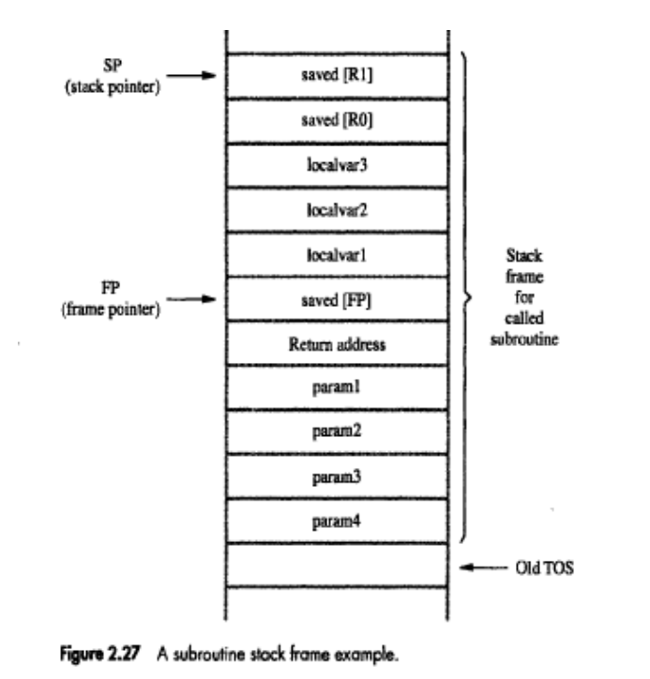
The pointers SP and FP are manipulated as the stack frame is built, used, and
dismantled for a particular of the subroutine. We begin by assuming that SP point to the old top-of-stack (TOS) element in fig b. Before the subroutine is called, the calling program pushes the four parameters onto the stack. The call instruction is then executed, resulting in the return address being pushed onto the stack. Now, SP points to this return address, and the first instruction of the subroutine is about to be executed. This is the point at which the frame pointer FP is set to contain the proper memory address. Since FP is usually a general-purpose register, it may contain information of use to the Calling program. Therefore, its contents are saved by pushing them onto the stack. Since the SP now points to this position, its contents are copied into FP.
Thus, the first two instructions executed in the subroutine are
Move FP, -(SP)
Move SP, FP
After these instructions are executed, both SP and FP point to the saved FP contents.
Subtract #12, SP
Finally, the contents of processor registers R0 and R1 are saved by pushing them
onto the stack. At this point, the stack frame has been set up as shown in the fig.
The subroutine now executes its task. When the task is completed, the Subroutine pops the saved values of R1 and R0 back into those registers, removes the local variables from the stack frame by executing the instruction.
Add #12, SP
And pops the saved old value of FP back into FP. At this point, SP points to the
return address, so the Return instruction can be executed, transferring control back to the calling program.
1.10 Logic instructions
Logic operations such as AND, OR, and NOT, applied to individual bits, are the basic building blocks of digital circuits, as described. It is also useful to be able to perform logic operations is software, which is done using instructions that apply these operations to all bits of a word or byte independently and in parallel. For example, the instruction
Not dst
SHIFT AND ROTATE INSTRUCTIONS:-
There are many applications that require the bits of an operand to be shifted right or left some specified number of bit positions. The details of how the shifts are performed depend on whether the operand is a signed number or some more general binary-coded information. For general operands, we use a logical shift. For a number, we use an arithmetic shift, which preserves the sign of the number.
Logical shifts:-
Two logical shift instructions are needed, one for shifting left (LShiftL) and
another for shifting right (LShiftR). These instructions shift an operand over a number of bit positions specified in a count operand contained in the instruction. The general form of a logical left shift instruction is
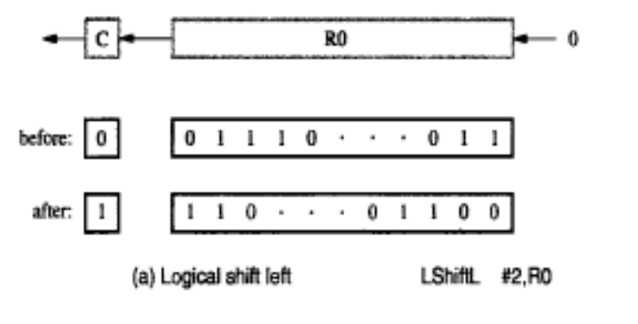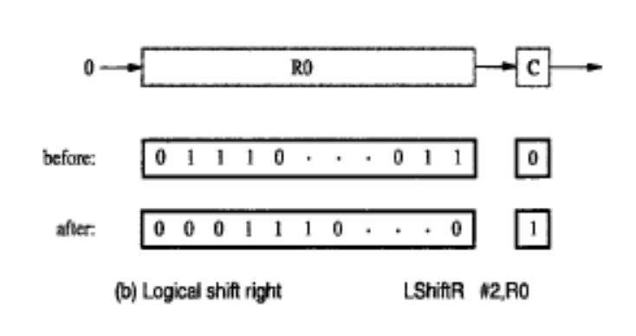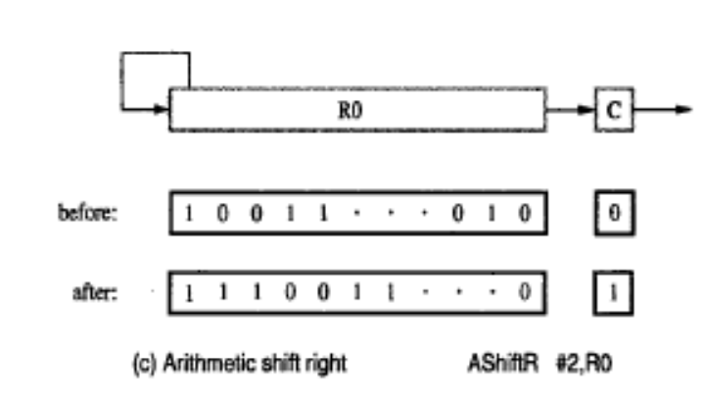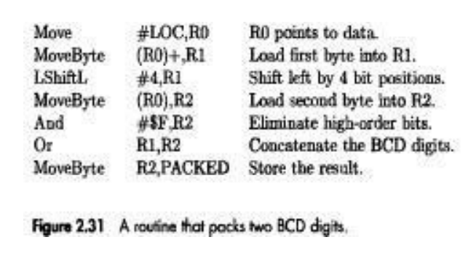
Rotate Operations:-
In the shift operations, the bits shifted out of the operand are lost, except for the
last bit shifted out which is retained in the Carry flag C. To preserve all bits, a set of rotate instructions can be used. They move the bits that are shifted out of one end of the operand back into the other end. Two versions of both the left and right rotate instructions are usually provided. In one version, the bits of the operand are simply rotated. In the other version, the rotation includes the C flag.
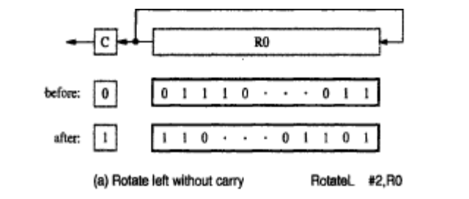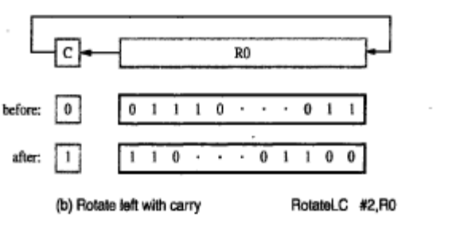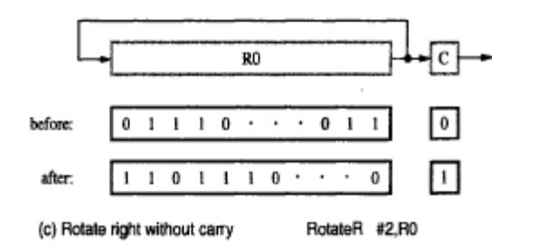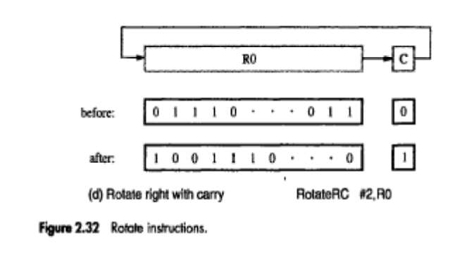
1.11 Byte Sorting Program: Consider a program for sorting a list of bytes stored in memory into ascending alphabetic order. Assume that the list consists of n bytes. Let the list stored in memory locations LIST through LIST + n – 1, and let n be a 32-bit value stored at address N. To do this, use straight selection sort algorithm. First, the largest number is found and placed at the end of the list in location LIST + n – 1. Then the largest number in the remaining sub list of n – 1 numbers is placed at the end of the sub list in location LIST + n – 2. The procedure is repeated until the list is sorted.
